Resume #2 – YYC DataCon Opportunities

Contents

Intro 1

My Top-Rated Skills Table 3

Pretty Graphs and Charts 4

Many More in Power BI Report! 4

PDF Export Available to Download for Free! 4

Portfolio Highlights / Summary 7

Special Shoutout to Automation! 8

Thank You, Dear Reader, RBC Associate 9

Free Keyboard Shortcuts as A Special Thank You Just for You! 9

Thank You #2 for Reading Today Only!!! Unsolicited Software Recommendations! 10

My Contact Information – Greg Stevens 10

# Intro

**Hello Again RBC,**

It's me, **Greg**, for the **second time**, of up to possibly fifteen...hopefully not! Each time gets a bit better.

**I am applying for all three of the YYC DataCon jobs. Details in adjoining Power BI Visualizations**.

Since last time, about a week ago, I have expanded my Power Query based, Jobbernator 2022, name subject to change.

I have expanded the `ml_skills` property of the `phApp` Job data. This let me see what Skills are tagged for each Job.

For each Skill, ranked by the number of Jobs that Skill is tagged in, I then entered three different five-star-style rating.

Those three numbers are input to a calculation, a simple average right now, but might be weighted by importance of those three columns later, that calculation returns the `SkillScore`.

This let me create a mind-blowing-to-me `Power BI` report that let me see what Jobs of the ﻿3﻿ I am interested in.

Btw, that 25 (now 3) is a **dynamically updating Power BI variable based on Total Jobs or Selected Jobs**! Cool. `#CountJobTitle`.

To my dismay, but not surprise, I am not very qualified for the **Director of API** role, but am extremely qualified for Full-stack Development, and various Engineering roles.

I may have not ranked myself high enough on areas where I feel I don't have the **scale** that you are asking for.

**I believe I can scale though! So please, consider me for anything!**

This report will help you see my self-grading on the extracted (NLP/natural language processing) that was done to get these jobs and skills into here.

Below you will find quick stats including Top Jobs, and Top Skills, with more info on other pages.

# My Top-Rated Skills Table

|  |  |  |
| --- | --- | --- |
| Skill | Calculated Score % | Jobs Wanting Skill |

**a**

|  |  |  |
| --- | --- | --- |
| agile development | 120 | 1 |
| analytical mind | 120 | 1 |
| commitment to quality | 120 | 1 |
| continuous delivery | 120 | 1 |
| continuous learning | 120 | 2 |
| great attention to detail | 120 | 1 |
| helping others | 120 | 2 |
| object-oriented design | 120 | 1 |
| resiliency | 120 | 1 |
| trustworthiness | 120 | 1 |
| agile mindset | 100 | 2 |
| api | 100 | 1 |
| apis | 100 | 2 |
| application frameworks | 100 | 2 |
| applications | 100 | 4 |
| attention to detail | 100 | 1 |
| communication | 100 | 4 |
| continuous integration | 100 | 2 |
| design thinking | 100 | 2 |
| developer | 100 | 1 |
| excellent communication | 100 | 1 |
| flexible | 100 | 2 |
| git | 100 | 1 |
| github | 100 | 1 |
| impact | 100 | 3 |
| machine learning | 100 | 1 |
| mentoring | 100 | 1 |
| mysql | 100 | 3 |
| organizational skills | 100 | 1 |
| ownership | 100 | 1 |
| performance | 100 | 2 |
| private cloud | 100 | 2 |
| programming language | 100 | 1 |
| relational databases | 100 | 3 |
| rest apis | 100 | 2 |
| restful api | 100 | 1 |
| software engineer | 100 | 1 |
| software engineering | 100 | 3 |
| sql | 100 | 2 |
| stakeholders | 100 | 2 |
| strong communication skills | 100 | 3 |
| supportive | 100 | 2 |
| technical design | 100 | 1 |
| computer science | 93 | 3 |
| orchestration | 93 | 1 |
| public cloud | 93 | 2 |
| identity management | 87 | 1 |
| java | 87 | 3 |
| platforms | 87 | 1 |
| redis | 87 | 2 |
| aws | 80 | 2 |
| big data platforms | 80 | 1 |
| leaders | 80 | 2 |
| microsoft azure | 80 | 1 |
| work/life balance | 80 | 2 |
| jenkins | 73 | 1 |
| sql server | 73 | 2 |
| elasticsearch | 70 | 2 |
| angular | 67 | 1 |
| machine learning pipelines | 67 | 1 |
| python programming | 67 | 1 |
| articulate | 60 | 3 |
| docker | 60 | 2 |
| python programming language | 60 | 1 |
| scala programming | 60 | 1 |
| spring boot | 60 | 2 |
| python | 53 | 2 |
| big data technologies | 47 | 2 |
| mongodb | 47 | 2 |
| data products | 40 | 2 |
| kubernetes | 40 | 2 |
| kafka | 33 | 3 |
| scala | 20 | 1 |
| spark | 13 | 3 |
| hadoop | 7 | 3 |
| openshift | 0 | 2 |

# Pretty Graphs and Charts

## Many More in Power BI Report!

* You can download from the GitHub repo for this resume.
* Power BI Report will require the Excel Workbook with Power Query and Power Pivot Models.
* Plus some Power Pivot Tables that Power BI reads from.

## PDF Export Available to Download for Free!

* Beautiful PDF Export is Available
* This resume is built from parts of that report.
* I would have submitted that report, but some preliminary testing of a few PDF extractors showed that it would not pass the PDF parser likely being used by the Applicant Tracking System (ATS) that RBC Jobs is using, [Workday](https://www.workday.com/en-us/products/human-capital-management/overview.html) Human Capital Management (HCM) and HR Platform.
* <https://demo.pd3f.com/result/33H7Qfkv4f3u5Yxu4JZQYG/>
* Top skills were absolutely used in wording this content.
* I would normally hire a content writer but that doesn’t prove how well I can write content too!
* I am going to be passing a weighted list of keywords past this resume afterword, adding, refining, as I see fit 😉
* Resume hacking with Power Query / Business Intelligence / Natural Language Processing (NLP)! 🕵️‍♀️ 🦹‍♂️ ⌨ with a touch of personality.

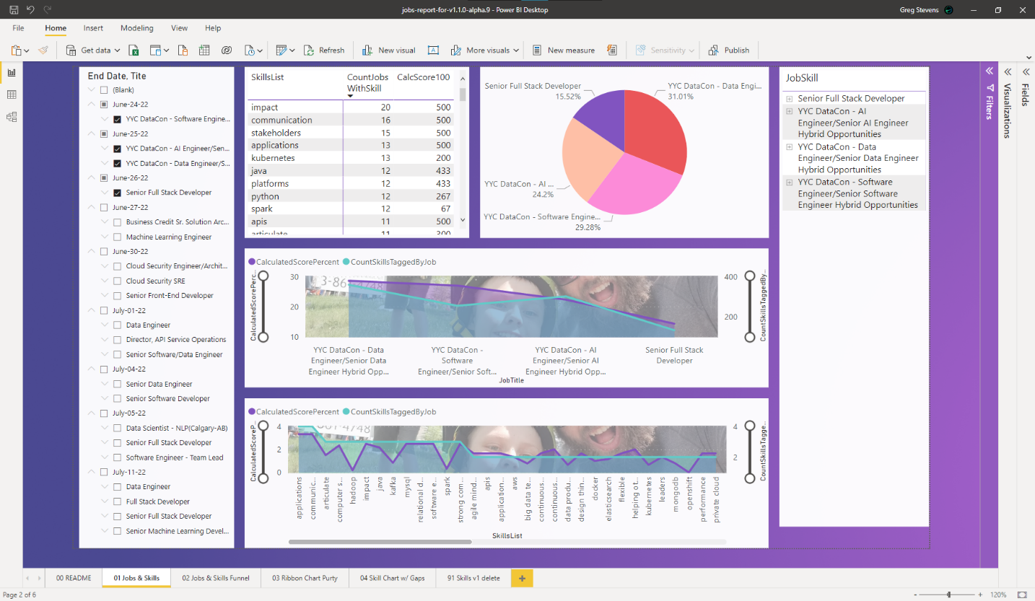

# Portfolio Highlights / Summary

|  |  |
| --- | --- |
| Site | Name |
| ronmor.ca |  |
| specialistlink.ca |  |
| beefresearch.ca |  |
| parkland.ca |  |
| vermilionenergy.com |  |
| enerplus.com |  |
|  |  |
|  | PNE Tracker |
|  |  |
|  |  |
|  |  |
|  |  |
|  |  |
|  |  |
|  |  |
|  |  |
|  |  |
|  |  |
|  |  |

# Special Shoutout to Automation!

Even this document was automated as much as possible, using text parts for instance to set the title for the Title of the document, and the header, which also uses a dynamic author name, file name, and date selector (I may automate but I kinda like setting the date).

Having that information dynamic means I can save this file as whatever version I create, and it will update in the header, automatically, without me needing to check, or forgetting and being unprofessional. That means I can track it, refine it, know what version had a typo or flat-out error in it.

*High Attention to Detail, High Quality of Detail, some other spammy keywords 😉*

* Hopefully I don’t need to do that, since I am hoping to get a job with you, RBC!
* I should automate the client name too, but that feels heartless.
* Point is, I automate to prevent mistakes, human mistakes, and to allow for scaling as anyone can hop in and start doing with pre-defined automation rules, processes, documentation, in place.

Reduce errors, reduce client distrust, increase everyone’s happiness, MAKE THE WORLD BETTER, in the little way I can, through tech.

Checkout <https://career.stevens.pro/betterweb> for more information on my purpose, TO MAKE THE WEB BETTER, which has been refined into TO MAKE ____ BETTER, then expanded into TO MAKE THE WORLD BETTER!

Okay, I am blabbing, somehow it turned into 1am.

# Thank You, Dear Reader, RBC Associate

* Your time is appreciated.
* Any feedback is even more appreciated.
* A chance for a new career is so greatly overwhelmingly appreciated I can’t express it in words 🤗.
* Tried to be as concise as possible. CONCISE is my new goal. Was BETTER before.
* I am sure this wasn’t easy, but rest assured, with feedback, it will get easier.
* Plus… **I think my little personal ATS / job matcher upper (term?) / Jobbinator 3000, could easily be expanded to load up all your jobs, and all your applicants**. Next step is to integrate it to:
* Count times skill mentioned on my website <https://career.stevens.pro/>
* Powered by [www.obsidian.md](http://www.obsidian.md)
* Either search site, which is a big JS package and kind of gross to hit through the URL, doesn’t even 404 properly ☹
* Web search not possible, will search the collection of 400+ markdown pages and related files.
* Search using Google Indexed Content
* Screaming Frog SEO Spider
* Twitter, Instagram, various other Social Media Platforms.
* Perhaps I have made a recruiter dream tool? Lolz, everyone says that about anything they build.

## Free Keyboard Shortcuts as A Special Thank You Just for You!

*Joking about just for you, they are for everyone, like almost everything should be, please share! #OpenSourceForLife*

* WIN+K = Connect Device
* WIN+ALT+D = Show Date/Time/Calendar
* WIN+LEFT/RIGHT ARROW = Snap Left/Right
* WIN+ALT+TAB = Task Switcher (nicer alt+tab w/ Virtual Desktops)
* Download Microsoft PowerToys
* Use the Shortcut Assistant to see most Windows Keyboard Shortcuts for a screen.
* Use the Virtual Mic/Cam w/ global blackout hotkeys.
* Use the Task Switcher / Launcher to be faster, better, stronger.
* Press WIN+X+A to launch a PowerShell w/ Admin Privileges, then type the below to install:
* winget install PowerToys
* *I have not tested that…package name may not be right. Use the below to find out:  
  winget search PowerToys*

## Thank You #2 for Reading Today Only!!! Unsolicited Software Recommendations!

* Diagramming? Brainstorming? Use [Excalidraw | Hand-drawn look & feel • Collaborative • Secure](https://excalidraw.com/)
* *Really Brainstorming? Try XMind*
* Second Brain? [www.Obsidian.md](http://www.Obsidian.md)
* Not down local file security? Want something “easier”? Then use [www.notion.so](http://www.notion.so), like my child, who understands Kanban boards now, and works off them for his chores, schoolwork, etc.

# My Contact Information – Greg Stevens